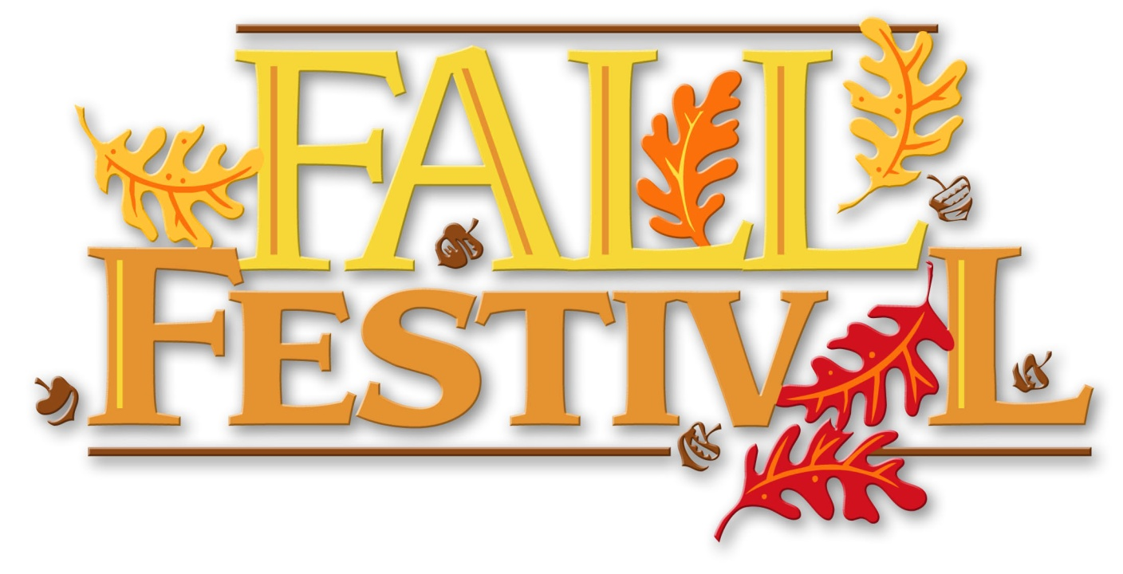

**For DBA Minister’s Wives! Thurs. Eve., Nov 3 6:30 to 8:30 pm Dannie & Gwen Williams’ Barn House 339 Mill Creek Road, Lyons**

**We hope you’ll join us for a FUN evening, some GOOD food, & AWESOME fellowship! We’re planning on a GOOD time!!!**

**Meet @ FBC Lyons at 6:00 pm to travel out on the bus together.**

**Wear comfortable clothes & shoes for a relaxed evening at the barn! We’re looking forward to this SPECIAL time, Your DBA Minister’s Wives Ministry Team**

**Questions? Call Gwen @ 912-293-2588**